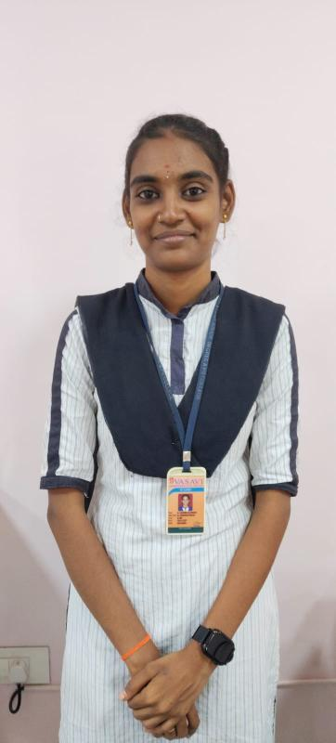
TEAM LEADER
MAGANTI LAKSHMI RAJESWARI
TEAM ID :LTVIP2026TMIDS58773
Rajeswarimaganti097@gmail.com
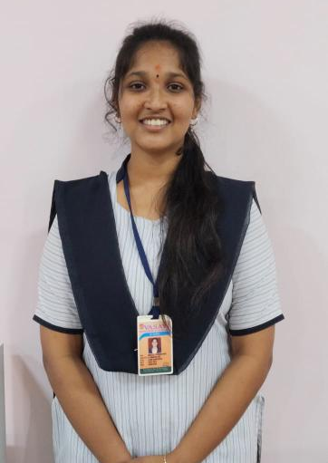

TEAM MEMBER 1
MENA BALA LAKSHMI VYSHNAVI DEVI
menalakshmidevi@gmail.com

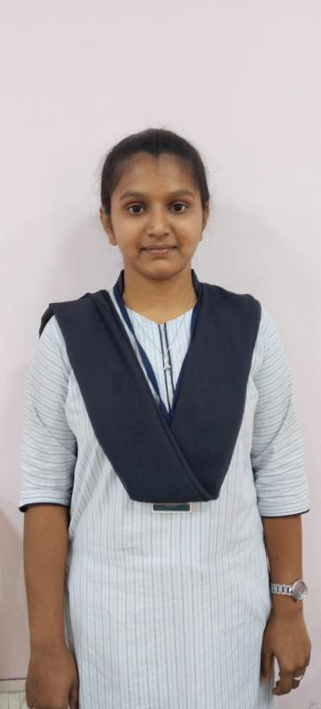

TEAM MEMBER 2
Gandi Anusha
anushagandi321@gmail.com

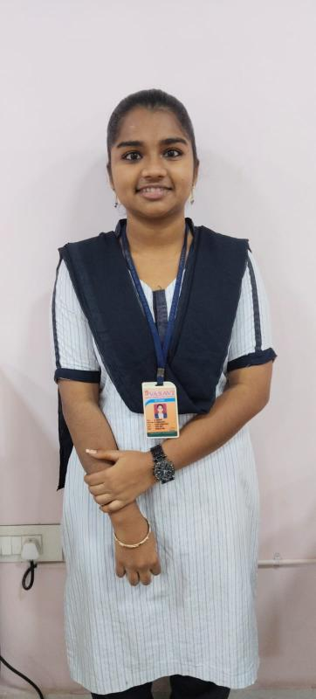
TEAM MEMBER 3
Badamsettti Indrani
indhubadhamsetti12@gmail.com

